ILP Project Plan:

Improving and Increasing Knowledge of The Unreal Engine

### I. Project Overview:

For the independent learning plan, I have been asked to further develop a certain skill within game development, I have chosen to broaden my knowledge of the unreal game engine. I will learn and showcase different aspect of game development within unreal engine, the techniques I want to explore are as followed.

* Audio Implementation
* Visual effects
* Cinematic Cutscenes
* Lighting

### II. Reasoning:

The reasoning behind this project are as followed;

* Increase employability, expands the range of jobs I can apply for as shown in Appendix H.
* Add an additional engine to my catalogue of knowledge.
* Additional work to add to my portfolio.
* Adding additional skill/tools that I haven’t learnt or used before.
* Improve the overall quality of games I create using the skills I learn.

### III. Objectives:

**Audio Implementation:**

The aspects of audio I will be exploring, and implementing is ambient and environmental game music and sound effects. I will demonstrate different types of attenuation shapes and how they affect the way the sound is heard. I will also be exploring reverb effect and how they can craft the overall feel of the environment the player is in.

* Effects refers to diegetic sounds during gameplay that are produced by the player character or the game world, e.g. footsteps, gunshots, explosions. Call of duty is a great example of a game that uses these sound effects.
* Game music is non-diegetic, he main reason for it is to “set the games ambience”. (Quinn, 2008). A video I watched showed how different game music effects the games ambience. (UT3 Ambient Passes, 2008).

When researching audio in other projects and games I have found similarities in how they control and manipulate sound to craft the players experience;

* Ambient sound effects conform to the real world, the closer the player is to the source the louder the sound e.g. flame crackling when near torch, explosion louder when closer.
* Game music changes depending on the current environment the player is in for example in the game Doom the music changes from quiet electronic music when not in combat to heavy metal when in combat.

**Visual Effects:**

The aspect of visual effect I will be exploring and demonstrating will be creating various of different particle effects using the cascade tool within the particle system. I will also explore how to optimize these effects, so they don’t hinder performance. From my research I have noticed similarities between the effects used within other games and projects shown in Appendix B, the similarities include;

* Main body effect
* Additional effect on the edges, small sparks, fire embers, smoke
* Most effects are linear; however, some have noise in other directions
* Self-Illumination is used in most effects

**Cinematic Cutscenes:**

I will create and demonstrate a short cinematic cutscene using multiple camera’s, I will cycle through these cameras to give different perspective on the scene. I will also add a few skeletal meshes and add animation tracks to them. I will be using the sequencer tool within unreal to create the cutscene. Aspects I have seen in other games and projects shown in Appendix C;

* Animation tracks (Can animate the skeletal meshes during cutscene)
* Transform tracks (Allow skeletal mesh to move to another location during cutscene)
* Fade in and Fade out
* Multiple camera setup
* Camera track that paths through the level

**Lighting:**

I will be exploring how to correctly light a scene depending on the environment of the level, by looking at my research shown in Appendix D I have found similarities between other projects and games, and how they handle lighting in those environments;

* Main light source, typically coming from window or gap in the environment.
* Secondary light source coming from torches, lamps, flame.
* Light beams from windows.
* Shadow placement depending on the location of light source.
* Reflection in puddles and/or shiny objects.

### IV. Final Artifact:

In the final artefact, the aspects I have spoken about will be combined into a single scene in unreal, currently I do not know what ambience and environmental theme I will be trying to achieve as planned in week 3 of my schedule shown in Appendix A. However, I plan to have the following in the scene;

* Audio to the scene
  + Footsteps for the player character
  + Sound for the gun
  + Sound for the particle effects
  + Game music to create the ambience
  + Using different attenuation shapes to affect how the sound is heard
  + Adding reverb to the audio to craft a different feel
* Visual Effects
  + Creating several different effects e.g. Flame, smoke etc.
  + Adding additional effects on the side around the main body effect
  + Maintain performance when using effects
  + Add self-illumination to the effects
  + Create linear and non-linear effects
* Cinematic cutscene
  + Multi-camera cutscene
  + Fade in and out of cinematic
  + Using skeletal meshes with animation track
  + Cutscene that paths through the level
  + Adding audio track to the cutscene
* Lighting
  + Lighting a scene with different types of light
  + Adding shadows depending on the direction of the light source
  + Adding reflection probes, being careful about performance hit
  + Volumetric fog
  + Using different light mobility’s to see how it changes the lighting

### V. Management Technique

To achieve these goals, I will be working on the project for 8 – 16 hours a week. I will be using the agile management style as it gives me the freedom to go back during development. I will be using Trello to set and manage task and clockify to time them accurately, I will also use GitHub to back up my projects just in case something goes wrong.

Over the development process there is always the chance of risks, I have created a risk assessment to show the possible risks, impacts and outcomes (Appendix F).

I have also completed a work breakdown structure that clearly lays out the structure of the project, and my estimated time split of each aspect of the project (Appendix E).

### Appendix

### Appendix A

# Outline the steps/plan for your project:

|  |  |  |
| --- | --- | --- |
| **Project Milestones** | | |
| **2018-2019** | **Week #** | **Milestone Deliverables and Tasks** |
| 14/11/18 – 21/11/18 | **Week 1** | Research and planning project, writing project plan |
| 21/11/18 – 28/11/18 | **Week 2** | Continuing project plan ready for hand in |
| 28/11/18 – 5/11/18 | **Week 3** | Research map theme/Creating 4 separate scenes for each aspect |
| 5/12/18 – 12/12/18 | **Week 4** | Decide on the design and theme of the level |
| 12/12/18 – 19/12/18 | **Week 5** | Researching audio techniques used in games and other projects |
| 19/12/18 – 26/12/18 | **Week 6** | Implementing audio into my scene |
| 26/12/18 – 2/1/19 | **Week 7** | Continue to iterate audio in my scene |
| 2/1/19 – 9/1/19 | **Week 8** | Continue to iterate audio in my scene |
| 9/1/19 – 16/1/19 | **Week 9** | Continue to iterate audio in my scene |
| 16/1/19 – 23/1/19 | **Week 10** | Find and fix issues/bugs with audio |
| 23/1/19 – 30/1/19 | **Week 11** | Research Cinematic Cutscenes, research sequencer editor |
| 30/1/19 – 6/2/19 | **Week 12** | Implement Cutscene into scene |
| 6/2/19 – 13/2/19 | **Week 13** | Continue to iterate Cutscene in my scene |
| 13/2/19 – 20/2/19 | **Week 14** | Continue to iterate Cutscene in my scene |
| 20/2/19 – 27/2/19 | **Week 15** | Find and fix issues/bugs with Cutscene |
| 27/2/19 – 6/3/19 | **Week 16** | Research Lighting from other games and projects |
| 6/3/19 – 13/3/19 | **Week 17** | Implement Lighting into scene |
| 13/3/19 – 20/3/19 | **Week 18** | Continue to iterate Lighting in my scene |
| 20/3/19 – 27/3/19 | **Week 19** | Continue to iterate Lighting in my scene |
| 27/3/19 – 3/4/19 | **Week 20** | Continue to iterate Lighting in my scene |
| 3/4/19 – 10/4/19 | **Week 21** | Find and fix issues/bugs with Lighting |
| 10/4/19 – 17/4/19 | **Week 22** | Research particle effects in games and other projects |
| 17/4/19 – 24/4/19 | **Week 23** | Research Cascade tool within unreal |
| 24/4/19 – 1/5/19 | **Week 24** | Implement Particle effects into scene |
| 1/5/19 – 8/5/19 | **Week 25** | Continue to iterate Particles in my scene |
| 8/5/19 – 15/5/19 | **Week 26** | Continue to iterate Particles in my scene |
| 15/5/19 – 22/5/19 | **Week 27** | Continue to iterate Particles in my scene |
| 22/5/19 – 29/5/19 | **Week 28** | Find and fix issues/bugs with Particle Effects |
| 29/5/19 – 5/6/19 | **Week 29** | Implement all feature into a single scene/Start Evaluation |
| 5/6/19 – 12/6/19 | **Week 30** | Continue to implement and fix any issues and improvements/Evaluation |
| 12/6/19 – 19/6/19 | **Week 31** | Continue to implement and fix any issues and improvements/Evaluation |
| 19/6/19 – 26/6/19 | **Week 32** | Continue to implement and fix any issues and improvements/Evaluation |
| 26/6/19 – 3/7/19 | **Week 33** | Continue to implement and fix any issues and improvements/Evaluation |
| 3/7/19 – 10/7/19 | **Week 34** | Continue to implement and fix any issues and improvements/Evaluation |
| 10/7/19 – 19/7/19 | **Week 35** | Final checks ready for hand in |

### Appendix B

### Particle effect MoodBoard

### Appendix C

### Sequencer MoodBoard

### Appendix D

Lighting the scene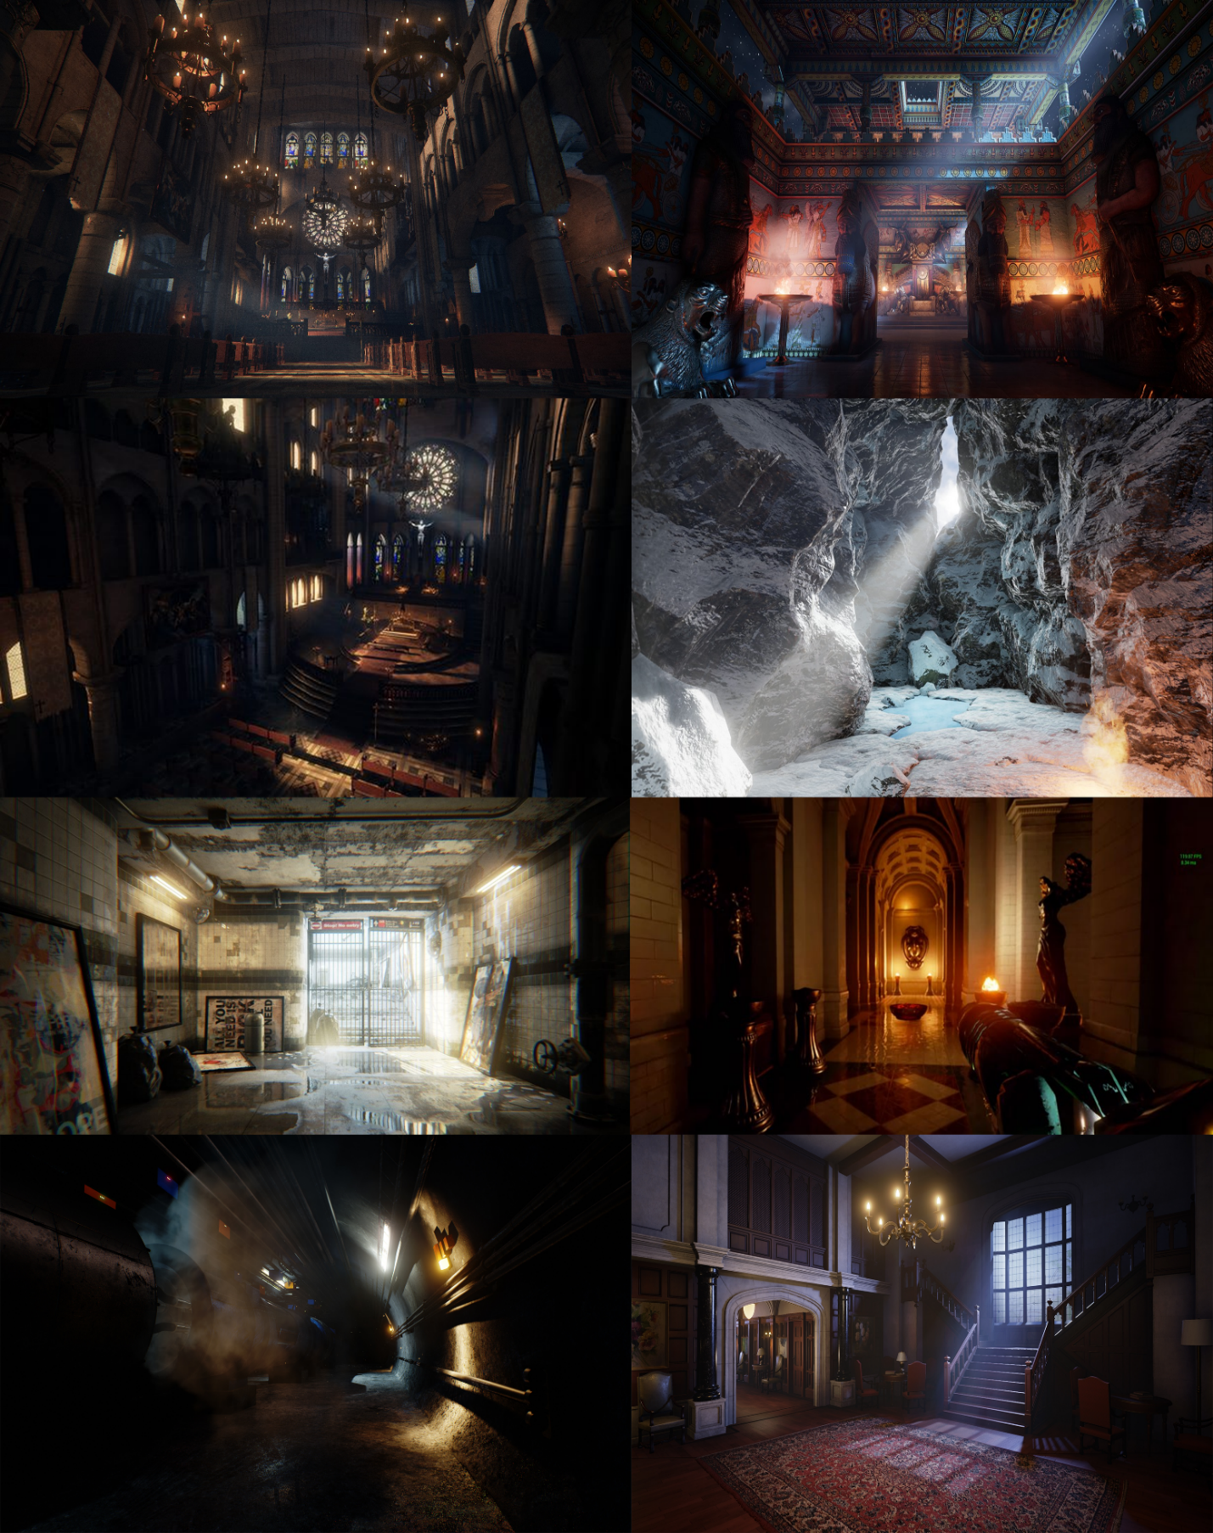

### Appendix E

### Appendix F

Possible Risks

* Over scope
* Technical Software issues
* Overlapping assignments
* Not completing tasks on time
* Spending too much time on research
* Not enough research

|  |  |  |  |
| --- | --- | --- | --- |
| **Likelihood** | **Impact** | **Combined** | **Risk** |
| 1 | 2 | 3 | Over scoping the project |
| 2 | 1 | 3 | Technical issues with unreal or tools within unreal, could cause delays on the project |
| 4 | 4 | 7 | Not researching enough for the project |
| 3 | 3 | 6 | Spending too much time researching and not implementing. |
| 6 | 6 | 12 | Not completing takes according to the week by week schedule |
| 5 | 5 | 10 | Overlapping assignments may cause schedule issues |

### Appendix H

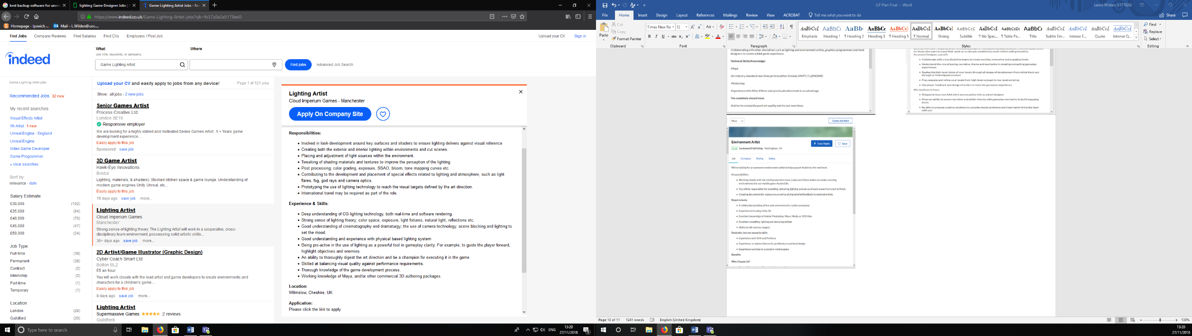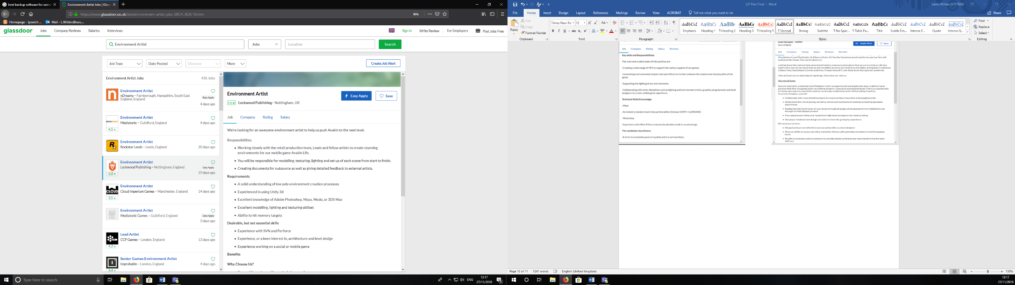

**Skills I will gain through this project for the jobs above;**

* Create wide range of VFX
* Industry standard particle editor (Cascade)
* Balancing visual quality against performance
* Creating both interior and exterior lighting
* Learning industry standard cutscene editor (Sequencer)
* Collaborate across other disciplines
* Strong sense of lighting Theory
* Thorough knowledge of the game development process

### Bibliography

A.-Moniem, M. (2015). *Unreal Engine lighting and rendering essentials*. Birmingham: Packt Publishing.

Majek, D. (2011). *The Cinematisation of Computer and Console Games*. Undergraduate. Stockholmes University.

Ordóñez, F. (2017). *VFX for Games Explained*.

Quinn, A. (2008). Types and Roles Of Sound In Games. [Blog] *Andrew Quinn, Sound Designer & Field Recordist*. Available at: http://www.aquinn.co.uk/wordpress/7 [Accessed 20 Nov. 2018].

*UT3 Ambient Passes*. (2008). [video] Directed by A. Quinn. Youtube.

Schmalz, M., Finn, A. and Taylor, H. (2014). Risk Management in Video Game Development Projects. *2014 47th Hawaii International Conference on System Sciences*. [online] Available at: https://ieeexplore.ieee.org/document/6759136 [Accessed 20 Nov. 2018].

Stevens, R. and Raybould, D. (2015). *Game Audio Implementation: A Practical Guide Using the Unreal Engine*. 1st ed. Abingdon: Routledge.